**STRING BASED TASK - 3**

**1. Write a program to check whether a given substring is present in the**

**given string.**

**Test Data :**

**Input the string : This is a test string.**

**Input the substring to be search : test**

**Expected Output :**

**The substring is not exists in the string.**

import java.util.Scanner;

public class SubstringCheck {

public static void main(String[] args) {

Scanner sc = new Scanner(System.in);

System.out.print("Input the string: ");

String mainString = sc.nextLine();

System.out.print("Input the substring to be search: ");

String subString = sc.nextLine();

if (mainString.contains(subString)) {

System.out.println("The substring exists in the string.");

} else {

System.out.println("The substring does not exist in the string.");

}

}

}

// OUTPUT:

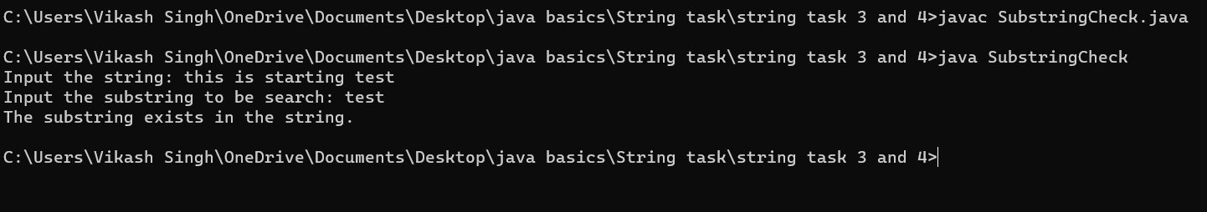

**2. Write a program in java to read a sentence and replace lowercase**

**characters by uppercase and vice-versa.**

**Test Data :**

**Input the string : This Is A Test String.**

**Expected Output :**

**The given sentence is : This Is A Test String.**

**After Case changed the string is: tHIS iS a tEST sTRING.**

import java.util.Scanner;

public class CaseToggle {

public static void main(String[] args) {

Scanner sc = new Scanner(System.in);

System.out.print("Input the string: ");

String input = sc.nextLine();

StringBuilder toggledString = new StringBuilder();

for (char c : input.toCharArray()) {

if (Character.isUpperCase(c)) {

toggledString.append(Character.toLowerCase(c));

} else if (Character.isLowerCase(c)) {

toggledString.append(Character.toUpperCase(c));

} else {

toggledString.append(c);

}

}

System.out.println("The given sentence is: " + input);

System.out.println("After Case changed the string is: " + toggledString);

}

}

// OUTPUT:

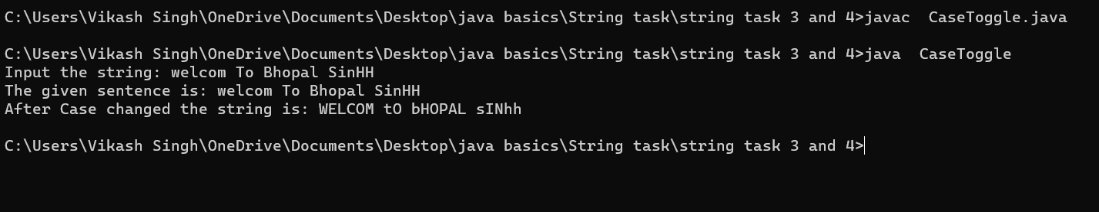

**3. Write a program in java to find the number of times a given word &#39;the&#39;**

**appears in the given string.**

**Test Data :**

**Input the string : The string where the word the present more than once.**

**Expected Output :**

**The frequency of the word &#39;the&#39; is : 3**

import java.util.Scanner;

public class WordFrequency {

public static void main(String[] args) {

Scanner sc = new Scanner(System.in);

System.out.print("Input the string: ");

String input = sc.nextLine();

String[] words = input.toLowerCase().split("\\s+");

int count = 0;

for (String word : words) {

if (word.equals("the")) {

count++;

}

}

System.out.println("The frequency of the word 'the' is: " + count);

}

}

// OUTPUT:

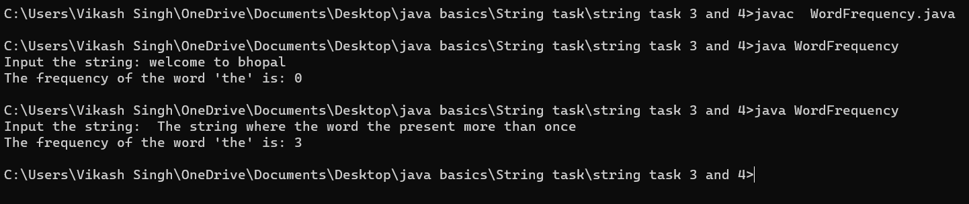

**4. Write a program in java to remove characters in String Except**

**Alphabets.**

**Test Data :**

**Input the string : wel123come456india**

**Expected Output :**

After removing the Output String : welcomeindia

import java.util.Scanner;

public class RemoveNonAlphabets {

public static void main(String[] args) {

Scanner sc = new Scanner(System.in);

System.out.print("Input the string: ");

String input = sc.nextLine();

String result = input.replaceAll("[^a-zA-Z]", "");

System.out.println("After removing the Output String: " + result);

}

}

// OUTPUT:

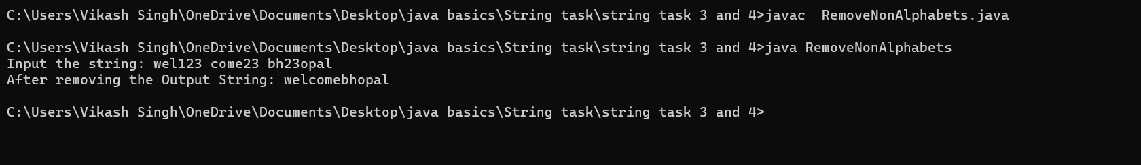

**5. Write a program in java to Find the Frequency of Characters.**

**Test Data :**

**Input the string : This is a test string**

**Input the character to find frequency: i**

**Expected Output :**

**The frequency of &#39;i&#39; is : 3**

import java.util.Scanner;

public class CharacterFrequency {

public static void main(String[] args) {

Scanner sc = new Scanner(System.in);

System.out.print("Input the string: ");

String input = sc.nextLine();

System.out.print("Input the character to find frequency: ");

char target = sc.next().charAt(0);

int count = 0;

for (char c : input.toCharArray()) {

if (c == target) {

count++;

}

}

System.out.println("The frequency of '" + target + "' is: " + count);

}

}

// OUTPUT:

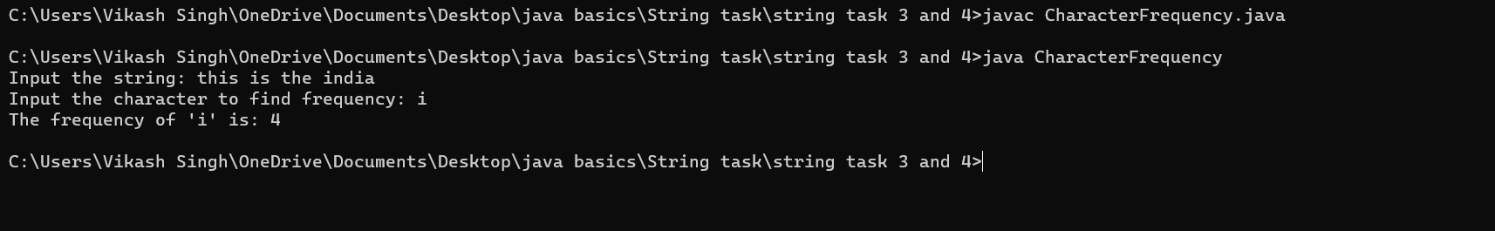

**STRING BASED TASK - 4**

1. Write a program in java to compare two strings

Test Data :

Check the length of two strings:

--------------------------------

Input the 1st string : aabbcc

Input the 2nd string : abcdef

String1: aabbcc

String2: abcdef

Expected Output : Strings are not equal.

import java.util.Scanner;

public class StringComparison {

public static void main(String[] args) {

Scanner sc = new Scanner(System.in);

System.out.println("Check the length of two strings:");

System.out.println("--------------------------------");

System.out.print("Input the 1st string: ");

String string1 = sc.nextLine();

System.out.print("Input the 2nd string: ");

String string2 = sc.nextLine();

System.out.println("String1: " + string1);

System.out.println("String2: " + string2);

if (string1.equals(string2)) {

System.out.println("Expected Output: Strings are equal.");

} else {

System.out.println("Expected Output: Strings are not equal.");

}

}

}

// OUTPUT:

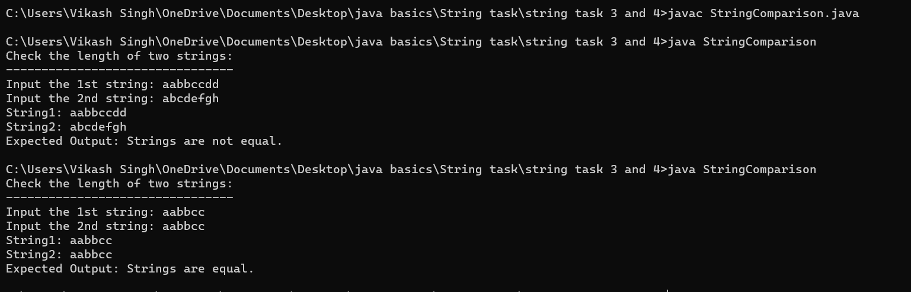

2. Write a program in java to count total number of alphabets, digits and

special characters in a string.

Test Data :

Input the string : Welcome to w3resource.com

Expected Output :

Number of Alphabets in the string is : 21

Number of Digits in the string is : 1

Number of Special characters in the string is : 1

import java.util.Scanner;

public class CountCharacters {

public static void main(String[] args) {

Scanner sc = new Scanner(System.in);

System.out.print("Input the string: ");

String input = sc.nextLine();

int alphabets = 0, digits = 0, specialChars = 0;

for (char c : input.toCharArray()) {

if (Character.isLetter(c)) {

alphabets++;

} else if (Character.isDigit(c)) {

digits++;

} else if (!Character.isWhitespace(c)) {

specialChars++;

}

}

System.out.println("Number of Alphabets in the string is: " + alphabets);

System.out.println("Number of Digits in the string is: " + digits);

System.out.println("Number of Special characters in the string is: " + specialChars);

}

}

// OUTPUT:

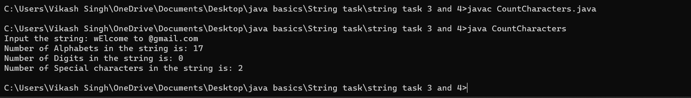

3. Write a program in Java to count total number of vowel or consonant

in a string.

Test Data :

Input the string : Welcome to w3resource.com

Expected Output :

The total number of vowel in the string is : 9

The total number of consonant in the string is : 12

import java.util.Scanner;

public class VowelConsonantCount {

public static void main(String[] args) {

Scanner sc = new Scanner(System.in);

System.out.print("Input the string: ");

String input = sc.nextLine().toLowerCase();

int vowels = 0, consonants = 0;

for (char c : input.toCharArray()) {

if (Character.isLetter(c)) {

if ("aeiou".indexOf(c) != -1) {

vowels++;

} else {

consonants++;

}

}

}

System.out.println("The total number of vowel in the string is: " + vowels);

System.out.println("The total number of consonant in the string is: " + consonants);

}

}

// OUTPUT :

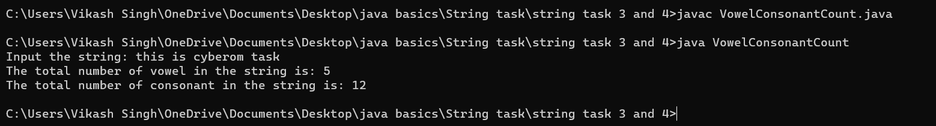

5. Write a java program to sort a string array in ascending order.

Test Data :

Input the string : wel4come

Expected Output :

After sorting the string appears like :

import java.util.Arrays;

import java.util.Scanner;

public class SortStringAscending {

public static void main(String[] args) {

Scanner sc = new Scanner(System.in);

System.out.print("Input the string: ");

String input = sc.nextLine();

char[] charArray = input.toCharArray();

Arrays.sort(charArray);

String sortedString = new String(charArray);

System.out.println("After sorting the string appears like: ");

System.out.println(sortedString);

}

}

// OUTPUT;

